DAA LAB ASSIGNMENT – 7
Course: Design and Analysis of Algorithms (DAA)
Student Name: Lavanyadevi K
Student Reg. No: CH.SC.U4CSE24226
Department/Class: B. Tech CSE – C (2nd yr)

Q1. Job Sequencing with Deadlines
Question
Write a C program to implement Job Sequencing with Deadlines to schedule jobs such that the maximum profit is obtained.

Algorithm / Logic
- Read the number of jobs.
- For each job, read profit and deadline.
- Sort the jobs in descending order of profit.
- Find the maximum deadline to determine the number of time slots.
- Create an array of slots and initialize them as empty.
- For each job in sorted order:
  - Check the slot equal to its deadline.
  - If the slot is empty, assign the job.
  - If the slot is already occupied, move to the previous slot.
- Continue this process until all jobs are scheduled or no slots remain.
- Display the scheduled jobs and maximum profit.

Step-by-Step Computation / Explanation:
Consider the following example jobs:
Job | Profit | Deadline
J1 | 100 | 2
J2 | 19 | 1
J3 | 27 | 2
J4 | 25 | 1
J5 | 15 | 3
Step 1 – Sort Jobs by Profit
Arrange the jobs in descending order of profit.
Job | Profit | Deadline
J1 | 100 | 2
J3 | 27 | 2
J4 | 25 | 1
J2 | 19 | 1
J5 | 15 | 3

Step 2 – Create Time Slots
Maximum deadline = 3
So available slots:
Slot1 Slot2 Slot3

Step 3 – Assign Jobs Greedily
Job J1 (profit 100, deadline 2)
→ Place in Slot 2
Slot1 Slot2 Slot3
- J1 -

Job J3 (profit 27, deadline 2)
→ Slot 2 occupied → place in Slot 1
Slot1 Slot2 Slot3
J3 J1 -

Job J4 (profit 25, deadline 1)
→ Slot 1 already filled → cannot schedule.

Job J2 (profit 19, deadline 1)
→ Slot 1 already filled → cannot schedule.

Job J5 (profit 15, deadline 3)
→ Place in Slot 3
Slot1 Slot2 Slot3
J3 J1 J5

Step 4 – Compute Total Profit
Total Profit = 100 + 27 + 15
= 142
Thus, the selected jobs are:
J3 J1 J5

C Program
#include <stdio.h>

struct Job
{
int id;
int profit;
int deadline;
};

int main()
{
int n,i,j;
struct Job temp;

printf("Enter number of jobs: ");
scanf("%d",&n);

struct Job jobs[n];

for(i=0;i<n;i++)
{
printf("Enter profit and deadline for job %d: ",i+1);
scanf("%d%d",&jobs[i].profit,&jobs[i].deadline);
jobs[i].id=i+1;
}

for(i=0;i<n-1;i++)
{
for(j=i+1;j<n;j++)
{
if(jobs[i].profit < jobs[j].profit)
{
temp=jobs[i];
jobs[i]=jobs[j];
jobs[j]=temp;
}
}
}

int maxDeadline=0;

for(i=0;i<n;i++)
{
if(jobs[i].deadline>maxDeadline)
maxDeadline=jobs[i].deadline;
}

int slot[maxDeadline];

for(i=0;i<maxDeadline;i++)
slot[i]=-1;

int totalProfit=0;

for(i=0;i<n;i++)
{
for(j=jobs[i].deadline-1;j>=0;j--)
{
if(slot[j]==-1)
{
slot[j]=jobs[i].id;
totalProfit+=jobs[i].profit;
break;
}
}
}

printf("\nScheduled Jobs:\n");

for(i=0;i<maxDeadline;i++)
{
if(slot[i]!=-1)
printf("Job %d ",slot[i]);
}

printf("\nMaximum Profit = %d",totalProfit);

return 0;
}

Output
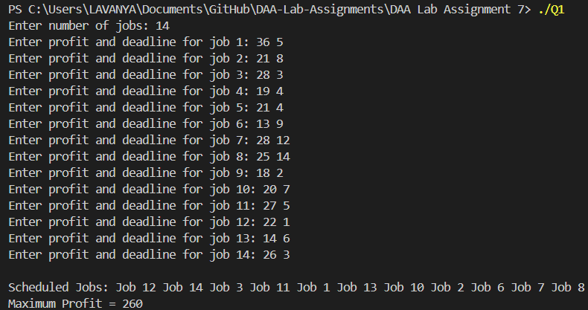

Interpretation
Job Sequencing with Deadlines is a greedy algorithm that schedules jobs based on maximum profit while satisfying deadlines. Jobs with higher profit are selected first and assigned to the latest available slot before their deadline to maximize total profit.

Q2. Huffman Coding
Question
Write a C program to implement Huffman Coding to generate optimal prefix codes for characters in a given string.

Algorithm / Logic
- Read the input string.
- Calculate the frequency of each character in the string.
- Create a node for each character and insert them into a list.
- Select the two nodes with the smallest frequencies.
- Combine them into a new node with frequency equal to their sum.
- Insert the new node back into the list.
- Repeat the process until only one node remains.
- Traverse the Huffman tree and assign:
  - 0 for left branch
  - 1 for right branch
- Display the Huffman codes for each character.

Step-by-Step Computation / Explanation:
Input String:
AMRITA VISHWA VIDYAPEETHAM

Step 1 – Compute Character Frequencies
Character | Frequency
A | 5
M | 2
R | 1
I | 3
T | 2
V | 2
S | 1
H | 2
W | 1
D | 1
Y | 1
P | 1
E | 2

Step 2 – Arrange Frequencies in Ascending Order
1 → R, S, W, D, Y, P
2 → M, T, V, H, E
3 → I
5 → A

Step 3 – Combine Two Smallest Frequencies
Huffman coding repeatedly combines the two smallest frequencies.
Example merging steps:
R(1) + S(1) = 2
W(1) + D(1) = 2
Y(1) + P(1) = 2
Then continue merging:
2 + 2 = 4
2 + 2 = 4
Continue until one node remains, which becomes the root of the Huffman tree.

Step 4 – Assign Binary Codes
During tree traversal:
Left edge → 0
Right edge → 1
Example Huffman codes generated:
Character | Code
A | 01
I | 100
T | 1100
H | 1101
V | 1110
M | 1111
R | 0011
W | 0000
C Program
#include <stdio.h>
#include <stdlib.h>
#include <string.h>

#define MAX 256

struct Node {
char data;
int freq;
struct Node *left, *right;
};

struct Node* createNode(char data,int freq){
struct Node* node=(struct Node*)malloc(sizeof(struct Node));
node->data=data;
node->freq=freq;
node->left=node->right=NULL;
return node;
}

void printCodes(struct Node* root,int arr[],int top){

if(root->left){
arr[top]=0;
printCodes(root->left,arr,top+1);
}

if(root->right){
arr[top]=1;
printCodes(root->right,arr,top+1);
}

if(root->left==NULL && root->right==NULL){
printf("%c : ",root->data);
for(int i=0;i<top;i++)
printf("%d",arr[i]);
printf("\n");
}
}

int main(){

char str[200];
int freq[256]={0};

printf("Enter the string: ");
scanf(" %[^\n]",str);

int len=strlen(str);

for(int i=0;i<len;i++){
if(str[i]!=' ')
freq[str[i]]++;
}

struct Node* nodes[256];
int count=0;

printf("\nCharacter Frequencies:\n");

for(int i=0;i<256;i++){
if(freq[i]>0){
printf("%c = %d\n",i,freq[i]);
nodes[count++]=createNode(i,freq[i]);
}
}

while(count>1){

int min1=0,min2=1;

if(nodes[min2]->freq < nodes[min1]->freq){
int t=min1;
min1=min2;
min2=t;
}

for(int i=2;i<count;i++){
if(nodes[i]->freq < nodes[min1]->freq){
min2=min1;
min1=i;
}
else if(nodes[i]->freq < nodes[min2]->freq){
min2=i;
}
}

struct Node* left=nodes[min1];
struct Node* right=nodes[min2];

struct Node* parent=createNode('*',left->freq+right->freq);
parent->left=left;
parent->right=right;

if(min1>min2){
int t=min1;
min1=min2;
min2=t;
}

nodes[min1]=parent;
nodes[min2]=nodes[count-1];
count--;
}

int arr[100];

printf("\nHuffman Codes:\n");
printCodes(nodes[0],arr,0);

return 0;
}

Output
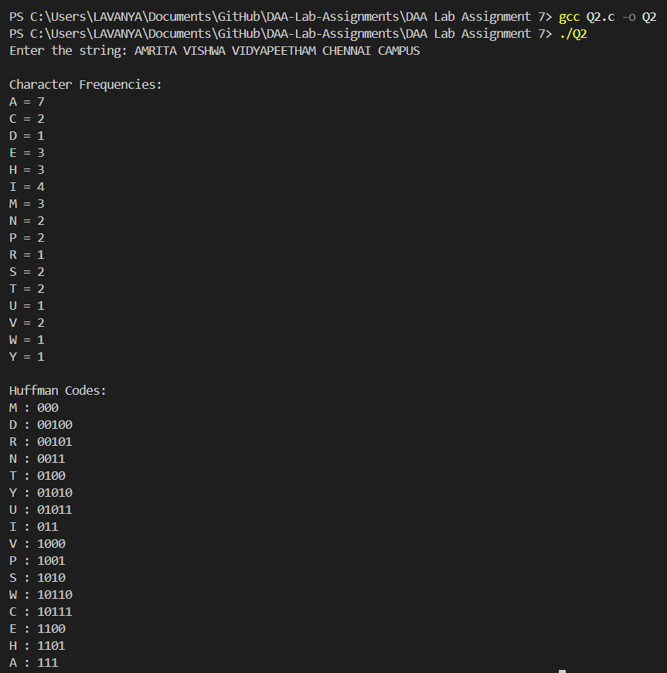

Interpretation
Huffman Coding is a greedy algorithm used for data compression. It assigns shorter binary codes to characters with higher frequency and longer codes to characters with lower frequency. This ensures optimal encoding and reduces the total number of bits required to represent the message.

